Create a resource group by using name , location and tags through powershell or azure portal

**Powershell commands:**

**Account-connect:**

Connect-AzAccount

**Resource group creation:**

New-AzResourceGroup -ResourceGroupName "sample" -Location "east us" -tag @{'resources'='loadbalancers'}

Get-AzResourceGroup -ResourceGroupName sample

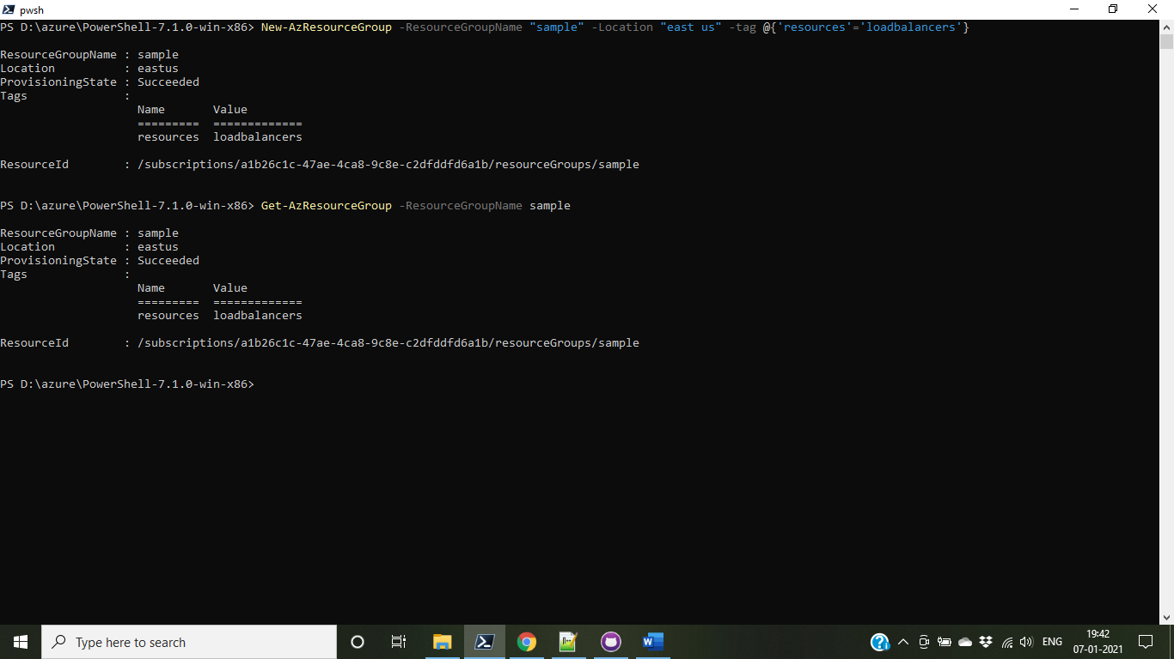

**Deploy arm template with locally stored json files:**

New-AzResourceGroupDeployment -Name test -ResourceGroupName sample -TemplateParameterFile "D:\azchlg\loadbalancer\azuredeploy.parameters.json" -TemplateFile "D:\azchlg\loadbalancer\azuredeploy.json"

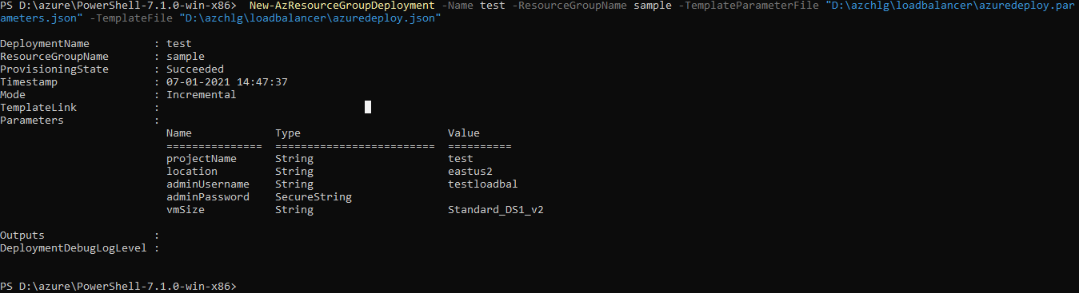

**Deploy arm template using uri:**

New-AzResourceGroupDeployment -Name test -ResourceGroupName sample -TemplateUri 'https://raw.githubusercontent.com/kamalanathan1995/azchlg/master/loadbalancer/azuredeploy.json' -TemplateParameterUri 'https://raw.githubusercontent.com/kamalanathan1995/azchlg/master/loadbalancer/azuredeploy.parameters.json'

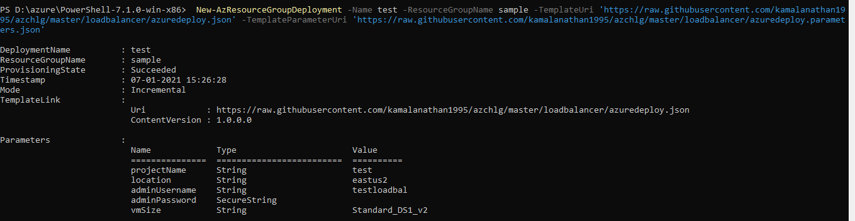

I have included command to install the web server on VM’s to test the load balancer connections:

# install IIS server role

Install-WindowsFeature -name Web-Server -IncludeManagementTools

# remove default htm file

remove-item C:\inetpub\wwwroot\iisstart.htm

# Add a new htm file that displays server name

Add-Content -Path "C:\inetpub\wwwroot\iisstart.htm" -Value $("Hello World from " + $env:computername)

Test success output:

